Activity: Q-Sorting Activity on Strategies for EV Evacuations

1. Summary
This activity uses Q-sorting to explore participants’ perspectives on the relative effectiveness of policies and strategies for supporting electric vehicle (EV) evacuations during extreme events. Participants review 10 strategies, arrange them on a sorting grid from less effective to more effective, and explain the reasoning behind their choices.
The activity encourages participants to consider different approaches to evacuation support, recognize tradeoffs, and reflect on what constitutes a successful evacuation. There is no single correct arrangement; the purpose is to capture perspectives and the experiences and assumptions that inform them.

2. Materials and preparation
Provide each participant with the Stakeholder Input PowerPoint (see attached ppt), which contains the strategy descriptions, sorting grid, and reflection questions. Participants can complete the exercise digitally by moving the strategy cards within the slide. Alternatively, the instructor can print the strategy cards, sorting grid, and questions for a paper-based activity.

Example of strategies could be:
- Backup energy from fossil fuels at public charging stations.
- Backup energy from microgrids at public charging stations.
- Free or open charging during emergency declarations.
- Mobile chargers deployed at evacuation origins.
- Mobile chargers supplementing existing charging locations.
- Mobile chargers at designated locations along evacuation routes.
- A minimum emergency charge reserve in EV batteries.
- Buses or shuttles to evacuate people.
- Staggered departures from evacuation zones.
- Minimum spinning reserves in the power grid.
Participants should review the complete descriptions in the presentation before sorting.

3. Activity procedure
First, ask participants to enter their names on the designated slide and read the strategy descriptions. The instructor should clarify any unfamiliar terms without suggesting how strategies should be ranked.
Next, ask participants to arrange all 10 strategy cards on the grid in response to the question:

“Which strategies or policies do you feel will be most or least effective at supporting evacuation of EVs during an extreme event?”

The grid ranges from −2, representing relatively less effective strategies, to +2, representing relatively more effective strategies.
It provides one position at −2, two at −1, four at 0, two at +1, and one at +2. Participants should place each strategy once and may rearrange their cards until the completed sort reflects their perspective.
After sorting, participants answer the reflection questions provided in the presentation:
- Why did you place the strategies at −2 and +2 as the least and most effective? Do you have real-world examples supporting your reasoning?
- Which strategies were most difficult to categorize, and why?
- What criteria did you use to sort the strategies? How would you define a successful evacuation?
- Are there additional policies or strategies that should be considered?

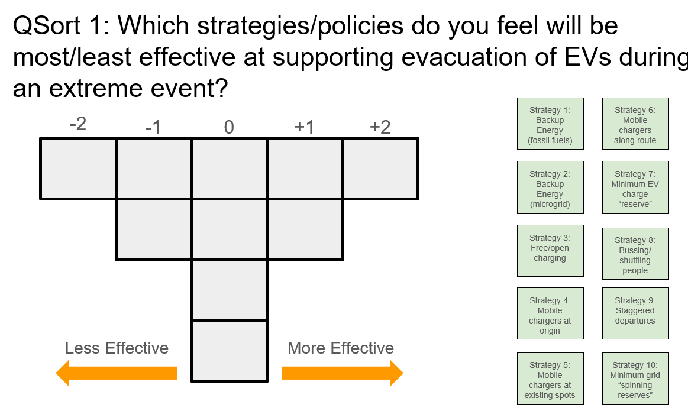

4. Expected output
Each participant submits a completed sorting grid and written responses to the reflection questions. The instructor can use these responses to facilitate discussion about shared priorities, differing perspectives, and the assumptions behind participants’ choices.

